

**Company Profile**

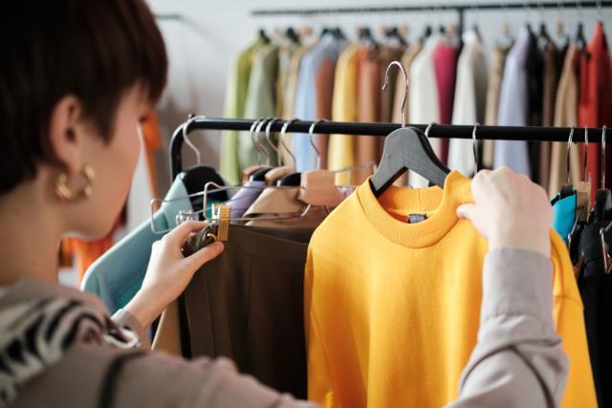

**About Us**

**“ASN Resources”** Established in early 2009 with an overview to establish a state of art Ready –made garments buying house and factory where buyers will feel real comfort to use the facility to produce their products. The company is having well experienced and highly professional staff and work forces they are main asset of **“ASN Resources”**. **“ASN Resources”** has a complete and systematic merchandising department with experienced merchandisers to cater the need of the customer. **ASN Resources** has a very strong sourcing capability of both imported and local. All so the sampling and development department under the guidance of the merchandisers are preparing and developing for the customers. We believe in welfare and safety of our workers. We are maintaining the highest standard of safety. We work by our ethical code known as BSCI code of conduct. We place our product ordered, we are very much conscious about child labor and also product quality. After a span of time, we are now well established in our goal. It is specialized in producing various styles of readymade garments Basic & Fancy **Woven Shirt/Blouse (Men’s, Boy’s & Girl’s) & school wear etc.** At present, the garments products are exported to all over the worlds, such as the United States, Germany, Switzerland, France, Netherland and UK. The company has advanced-technology; the monthly production capacity is **5,000,000 Pieces.**

**“ASN Resources”** has got the certificate of participating in making the National Quality Standards for garments fashion wears. Some of our products have been appropriated by international testing standard etc. Our company introduced the first-rate quality testing equipment, which provides reliable data for high-quality products. In the prices of creating healthy “seat culture”, our company persist in using the corporate culture to enhance the core competence in order to establish a good social image in the development.

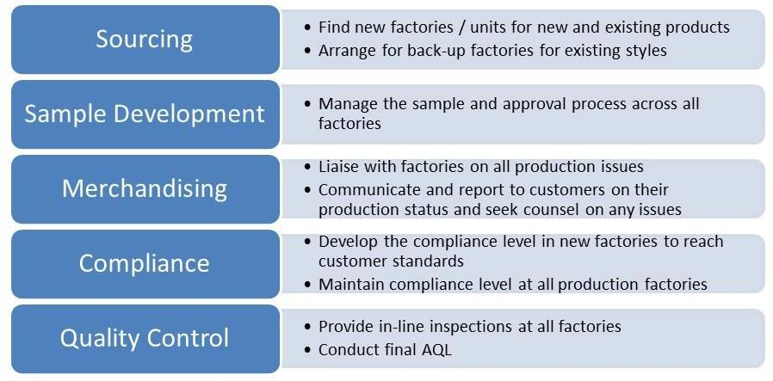

## 

## Trade & Market:

**Company Details**

|  |  |
| --- | --- |
| Main Markets: | USA, Europe & North America |
| Total Annual Sales Volume: | Above US$ 35.00 Million |
| Export Percentage: | 100% |
| QA/QC: | In House |
| No. of R&D Staff: | 30 People |

**PAYMENT TERMS:**

|  |  |
| --- | --- |
| Payment of L/C | At sight as per negotiating bank’s instruction. |
| L/C Available with/by | Credit is available with any bank in Bangladesh by negotiation at sight.  L/C must be subject to UCPDC 1993 revision ICC Publication no 500. |
| Type of Documentary Credit | Irrevocable and transferable. |
| Partial Shipment and Trans-Shipment | Allowed |
| B/L Clause | Full set clean on-board original bill of lading issued Unto the order of negotiating bank and endorsed by the Same bank in favor of L/C opening bank. |
| Presentation of Documents | 15 days from the date of bill of lading. |

|  |  |
| --- | --- |
| T/T Payment | 70% Advance for start production and balance 30% after inspection and before shipment. |

**Bank Details**

**Bank Asia PLC (Lien/Dealing Bank)** 

**Gulshan-2 Branch**

Address: Gulshan Palladium, Plot-1, Road-95,

Block CEN(C), Gulshan-2, Dhaka-1212, Bangladesh

Account name- ASN-Resources

Swift: BALBBDDH615

## NATURE OF BUSINESS

We are Ready Made Garments Buying House. We have been in the garments manufacturing and exporting by our affiliated factories since 2009.

## TYPE OF PRODUCTS (FLAT KNIT)

Sweater, Pullover, Cardigan, Vest, Ladies wear, Gent’s wear, Kids wear, and all kinds of latest fashion manufacturer.

## TYPE OF PRODUCTS (KNITWEAR & WOVEN)

T-shirt, Polo, Polar fleeces Hoodies, Jacket, Kid’s wear (any item), Ladies & Gents underwear, Tank top

Swimming shorts, Jacket/Outerwear, Shorts, Socks and many other fashionable items.

And many more exclusive products, like- All kinds of 100% Export Oriented leatheritems, Footwear, Home Décor etc.…

# **Laboratory Testing**

Laboratories are an extremely valuable component of our services and also facilitate the manufacturer – exporters to transact their business with least quality risk. Laboratory services include:

* **Fabric:** Construction particulars (counts, constructions and weight), Strength, Measurement and Seam performance.
* **Analysis:** Flammability, Dimensional Stability (Shrinkage) to washing / dry cleaning, Appearance after washing /dry cleaning, Fibber analysis, etc.
* **Color Fastness:** Color fastness to washing, Perspiration, Light, Rubbing, Bleaching, Dry cleaning, Organic Solvents, Hot pressing, etc. Dyes & Pigment tests are also carried out.

# **Quality Control Process:**

**“ASN Resources”** confirms the quality is the foundation of successful enterprise, its continuous works on maintaining a strict quality inspection and set up a complete, scientific and efficient system of quality inspection. **“ASN Resources”** regularly inspects and evaluates inner quality control system and keeps improving it. Now **“ASN Resources”** inspection Center is one of the best-equipped inspection Centers in Garments sector.

**Our Affiliated Factories**

* Taratex Fashion Limited
* Anannya Socks & Innerwear Limited
* MARMA composite Ltd.
* Crosswear Industries Ltd.
* Trust Knitwear Industries Ltd.
* IL Bangla Ltd. (Socks Factory)
* HR Textiles Ltd. (A Concern of Pride Group)
* Olympic Fashion Ltd.
* Dynasty Sweater Ltd.
* MultiFabs Ltd.
* Alema Textiles Ltd. (A Concern of MIM Group)
* Buildex Knit Composite Limited
* Natural Denims Ltd.
* A Plus Industries Limited
* That’s It Knit Limited (A Concern of Ha-meem Group)
* Loopdot Fashion Limited
* Azim & Son (Pvt.) Limited
* Euphoria Textiles (Garments Division)
* Maisha Mim Apparels Ltd.
* Hamko Footwear Limited
* Rose Intimates Limited
* Rose Sweater’s Ltd.
* Mim Sweater Ltd. & Others.

**Management Team**

**Abu Sayed Nayeem**

**Proprietor**

**Email:** [**asn.resources1@gmail.com**](mailto:asn.resources1@gmail.com)

[**nayeem@asn-resources.com**](mailto:nayeem@asn-resources.com)

**Cell: +16476854290**

**+8801716171313**

**Taruna Hasan**

Head of Operation

Email: [asn.resources2@gmail.com](mailto:asn.resources2@gmail.com)

[taruna@asn-resources.com](mailto:taruna@asn-resources.com)

Cell: +16476716228

**Shafia Begum**

Head Of Production

Email: [asn.resources3@gmail.com](mailto:asn.resources3@gmail.com)

[shafia@asn-resources.com](mailto:shafia@asn-resources.com)

Cell: +880171771771

**Gulay Rawsan (Mira)**

**Head of marketing**

**Email:** [asn.resources4@gmail.com](mailto:asn.resources4@gmail.com)

[gulay@asn-resources.com](mailto:gulay@asn-resources.com)

Cell: +8801611939911

**Mahdi Al Hassan (Russel)**

**Head of commercial**

**Email:** [asn.resources5@gmail.com](mailto:asn.resources5@gmail.com)

[mahdi@asn-resources.com](mailto:mahdi@asn-resources.com)

Cell: +8801811939911

**Our Customer (Major Brands & Buyers)**

01. DISNEY – ITALY

02. TAKKO, JEANS FRITZ, ADLER, KIK & NKD – GERMANY

03. GRUPPO COIN – ITALY

04. JOSE – ARGENTINA

05. PIAZZA – ITALY

06. HASICILLAR – TURKI

07. BAY CITY - GERMANY

08. P & B – PULL & BEAR

09. RICHLO

10. ZARA

11. MANGO

12. COSTCO

13. BERSHKA

14. MARISA

15. RENNER

16. MOTIVI

17. NEW LOOK

18. SPRINGFIELD

19. GEMO

20. Inbrands

21. NEXT

22. BJS

23. BUFFALO

24. Whisperring Smith

25. Guiddao Pero

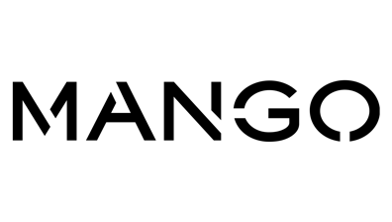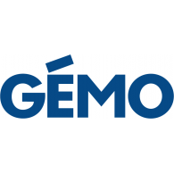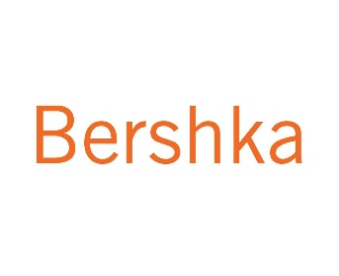

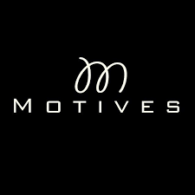

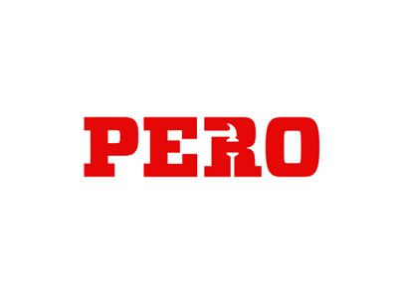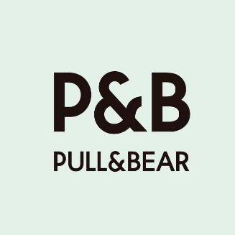****



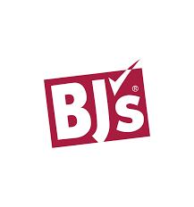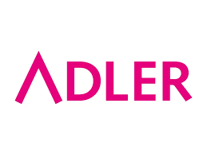

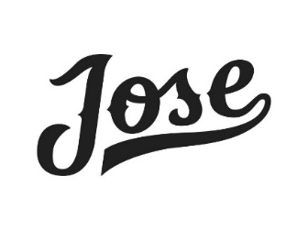

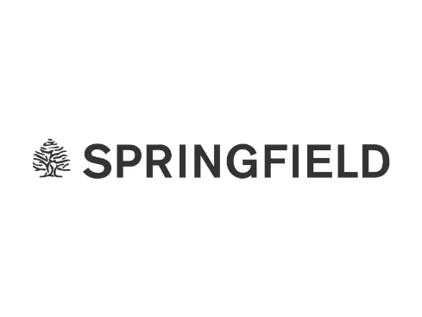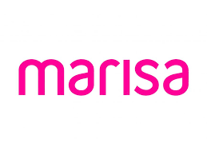

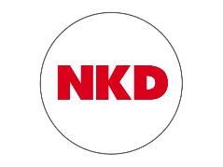





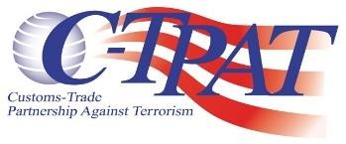

Our Business Policy

**ASN Resources** has its own business policy and it runs its business following those certain policies in every step. Basically, it is a garment or apparel trading company. It works as a buying agent or buying house also. We supply all types of ready-made garments as per our buyer’s requirements and choices.

We usually negotiate garment orders with our distinguished buyers. In this negotiation, we prioritize all aspects which allow our buyers to avail exclusive garments at the cheapest rate. When the orders are confirmed, we then transfer those to the manufacturing units. Then we arrange a discussion with the manufacturing units regarding the certain order and take all the necessary initiatives to execute the order. It is our main focus to ensure the shipment within the targeted time with buyer’s required quality of product. Considering this purpose **ASN Resources** moves forward with all types of supervision and leadership to the manufacturing units. A buyer usually places his/ her order from his/ her own country and he/ she can’t supervise his/ her order time to time. Due to this reason, the delivery of his/ her product becomes uncertain. To avoid this uncertainty, a buyer can place his/ her order through **ASN Resources** to ensure his/ her maximum safety. We declare our confidence that a buyer is always in a secured, safe and comfort zone with us. We possess a highly efficient QC team. They check piece to piece garment and ensure buyer’s required quality in every step from sourcing to shipment. We also have a vastly experienced merchandising team. They arrange all the raw materials and accelerate the production procedures in an organized way with the combination of QC team. Our merchandising team is a bridge of communication among our QC team, manufacturing units and buyers. Thus, with the help of this coordination, all of our orders become executed successfully.

There are 61+ foremost garment factories affiliated with us and all of them are compiled factories. So, welcome to **ASN Resources** for building a long-term business relation. We are always dedicated to you for a supreme service and world class apparels.

**Vision**

Our vision is to be the leading buying and trading house in the global apparel industry, known for our commitment to excellence, innovation, and sustainability. We aim to build long-term partnerships with our clients by consistently delivering products that exceed expectations.

**Quality & Compliance**

From the first sample, we take care of the quality at every step; we identify the key points of each product to anticipate possible difficulties in production. All of these actions are meant to decrease the margin of error. Our quality controller runs the most common tests on each and every order.

Our Quality Department is totally independent from the Merchandising and Production departments, their only goal is to achieve AQL quality requirement. Our Quality controller monitors and assured the production from the Pre-Production Sample validation to the Final Inspection. ANS RESOURCES offers a global solution for quality, adapted to the buyer’s needs.

We take immediate action on our client’s compliance and solve as per buyer requirements. We have various quality factories with all kinds of certifications as per the needs of the buyers.

**Our Services**

**Supplier Identification**

We identify new suppliers based on their product range, financial status, infrastructure, man power and efficiency of management. We continuously update our information on new manufacturers and new products. Information pertaining to new varieties of value additions, fabric, accessories, and new technology area and quota availability are also updated.

**Selection of Vendors**

We assess the factories in terms of product range, quality of the product made, production capacity, facilities, financial capability, technology orientation, man power, working conditions, managerial efficiency and their overall quality policy. Once our initial assessment is over, we exchange information with our principals and make a combined decision in approving an identified vendor.

**Sampling**

Samples are developed to suit the season’s colors, fabric and style based of our buyer’s requirements. Any number of sales man samples is made as per the buyer’s requirements and courier them directly to the buyers. By offering these crucial services, we assist our buyers marketing efforts in their own country by giving them an edge over others.

**Order execution and Quality Control (Quality Management)**

Orders are closely monitored from sampling to shipment. Status on sampling, production and shipment are transmitted to buyers regularly. We maintain a pro-active approach towards identification of problem areas and corrective measures are taken immediately to ensure timely deliveries. Our quality monitoring system pertaining to production has four stages as explained below:

* **Pre-Production Check**

Risks are reduced by checking material components, accessories / user manuals etc. at this stage itself.

* **Initial Production Check**

First finished products are checked against buyer’s specification and prototype sample. Deviations are identified and brought out for correction.

* **During Production Check**

Inspection during production is carried out to check and verify that the initial discrepancies have been rectified and to ensure the average quality standard of production runs.

**Status Reporting**

Status reports based on the multi-state inspections are transmitted to the buyers by fax or email. Production progress is analyzed in relation to the delivery terms and suitable course of action s taken to ensure goods are delivered in time. The consignment is allowed for shipment if only it is up to the buyers required standard

**Assists on Buyers visit**

We work with Group Factory in Bangladesh. We accompany our buyers on their buying visits, factory visits and inspection visits. We help them with and arrange their itinerary and accommodation on their visits. We also orient the buyer’s business practice in the country, its culture, customs and tradition to make their visit fruitful and enjoyable. All this at a cost which is actually a saving for our buyers! Yes, we reduce the cost of buying, cost of managing quality and cost of assuring deliveries. And, our customers get to know new developments, new products and new supply base from this part of the world.

**Research and Development**

As an expert in this area, we actively initiated the culture of healthy seating and spare no efforts to build a healthy and comfortable lift to every customer with fully inclusive and equitable design. Seating-own Simplified and refined character and style integrating with design aiming at Environment, safety and ergonomics; Meanwhile to create a new east- fashions culture endearingly.



**Corporate Office:**

Nakhastra (1st Floor-1/C), House: 1-A/2,

Block C, Avenue 3, Mirpur-2,

Dhaka-1216, Bangladesh

**Contact:** **+16476854290 / +8801716-171313**

**Email:** [**asn.resources1@gmail.com**](mailto:asn.resources1@gmail.com) **/** [**nayeem@asn-resources.com**](mailto:nayeem@asn-resources.com)

**Website:** [**www.asn-resources.com**](http://www.asn-resources.com)